**Blueberry Farming**

**Introduction**

In a study to determine the effectiveness of 5 methods of irrigating blueberry plants, ten blueberry farms were observed using the different methods, and they represented varieties of soil terrains and wind gradients. Each farm had five one-acre plots with an irrigation method assigned to it.

**Summary Statistics by Irrigation Method**

Above are the summary statistics for the weight categorized by the method of irrigation. The method with the highest mean weight is Surface irrigation at 616.3 and the second highest mean is Lateral at 497.6. In addition to having the highest means, they have the highest spreads, with Lateral having a minimum of 423.0 and a maximum of 580.0, and Surface has a minimum of 512.0 and a maximum of 690.0. The lowest spread range and mean is associated with the Trickle method with a mean of 353.2 and a spread of 248 to 423.

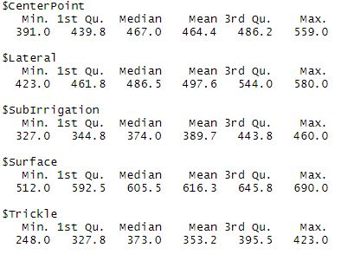

**Summary Statistics by Farm**

When analyzing the summary statistics by farm, Farm 9, Farm 4, and Farm 10 had the highest means with the weights being 500.2, 493.8, 493 respectively. Additionally, they had the highest spreads of weights compared to the other farms.

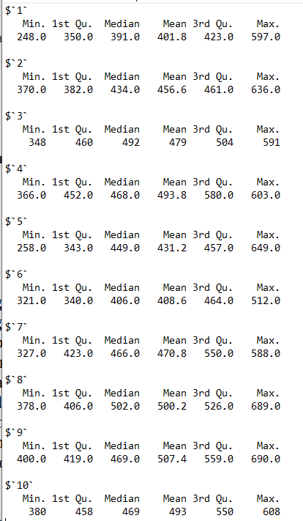

**ANOVA Table**

Based on the ANOVA table, it can be observed that both Irrigation Method and Farm as factors are statistically significant, but the method is more statistically significant than the farm as the p-value is much lower.

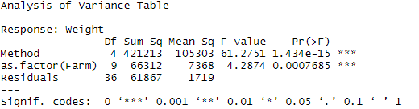

**Residuals vs. Fits**

Below is the Residuals versus Fits plot and based on it, there seems to be equal variance as the plotted residuals versus fits seem to be as equally distributed as possible without any distortion or cone shape of distribution arising.

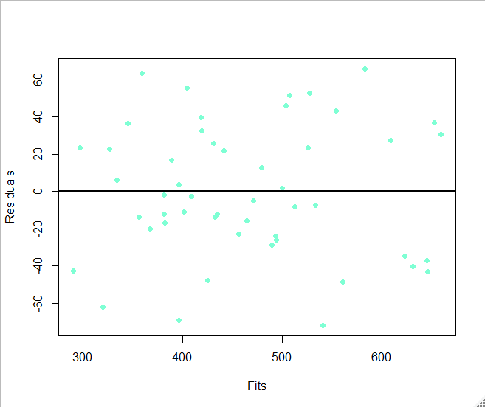

**Normal QQ Plot**

Based on the Normal QQ Plot, the assumption of normality holds up for the most part. There are some minor deviations from the normality assumption at the top and bottom of the line but most of the points are very close or on the line.

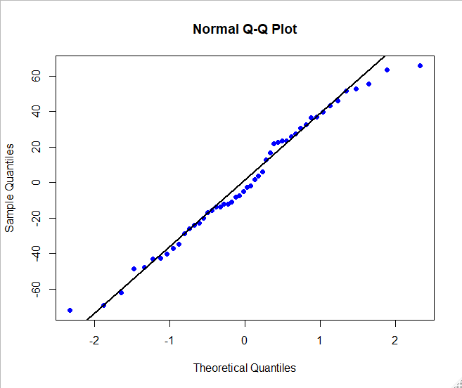

**Interaction Plot**

Observing the results from the interaction plot, there is some interaction between the Lateral and Surface Methods, and the Sub Irrigation and Trickle Methods. Of course based on the ANOVA table from earlier, Method and Farm are statistically significant so their interaction becomes statistically significant in the variance of weight.

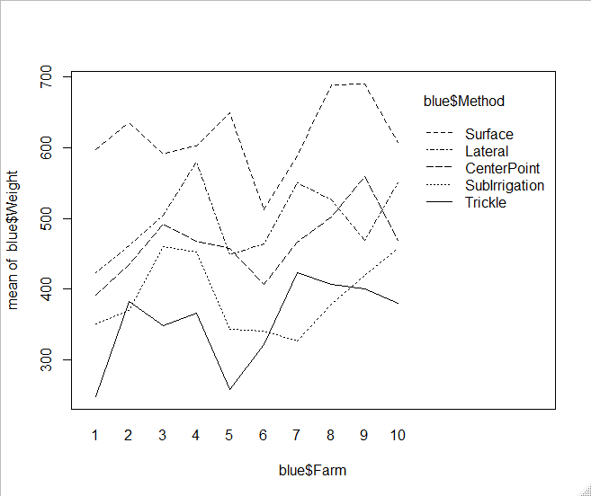

**TukeyHSD Intervals**

Analysis of the Tukey Intervals, the comparisons that are statistically significant are the Surface-CenterPoint, Trickle-CenterPoint, SubIrrigation-Lateral, Surface-Lateral, Trickle-Lateral, Surface-SubIrragation, and Trickle-Surface. The comparisons with the absolute lowest p-values included either the Surface or Lateral methods. In comparison, the Farm to Farm comparisons were not statistically significant when comparing the means, with the p, values exceeding 0.1

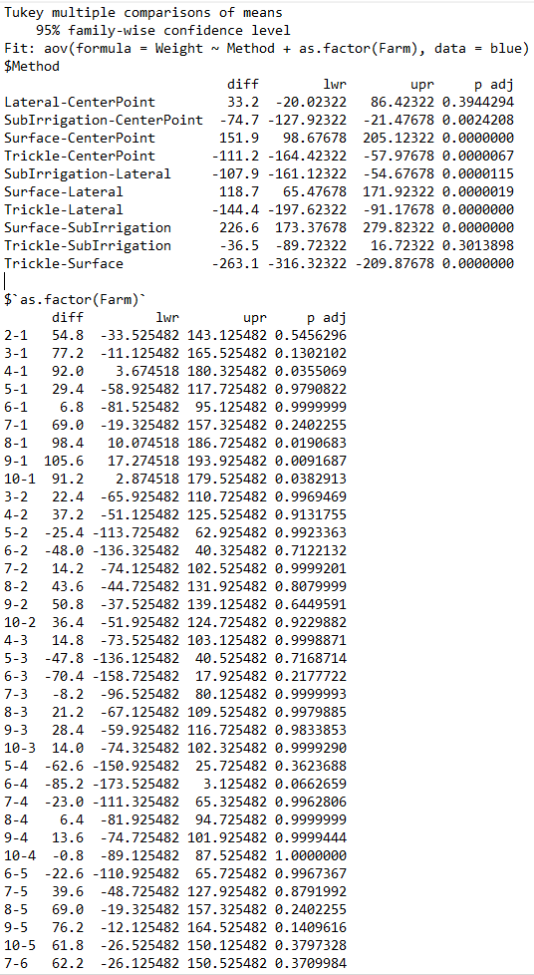

**Conclusion**

The blueberry weight study comparing different methods of irrigating the shrubs on ten different farms yielded important results on which irrigating method was the best for producing the heaviest blueberries. Based on the analysis of the means and spreads, the best irrigation method was Surface irrigation with the Lateral irrigation method being a close second. When observing the results from the ANOVA table, the method of irrigation was much more statistically significant to the growth of the blueberry shrubs than the farm.